Ideation Phase
Brainstorm & Idea Prioritization Template

Date | 26-06-2026
Team ID | Solo
Project Name | ShopEZ E-Commerce Application
Maximum Marks | 4 Marks

Brainstorm & Idea Prioritization Template:
Brainstorming provides a free and open environment that encourages everyone within a team to participate in the creative thinking process that leads to problem solving. Prioritizing volume over value, out-of-the-box ideas are welcome and built upon, and all participants are encouraged to collaborate, helping each other develop a rich amount of creative solutions.
Step-1: Team Gathering, Collaboration and Select the Problem Statement
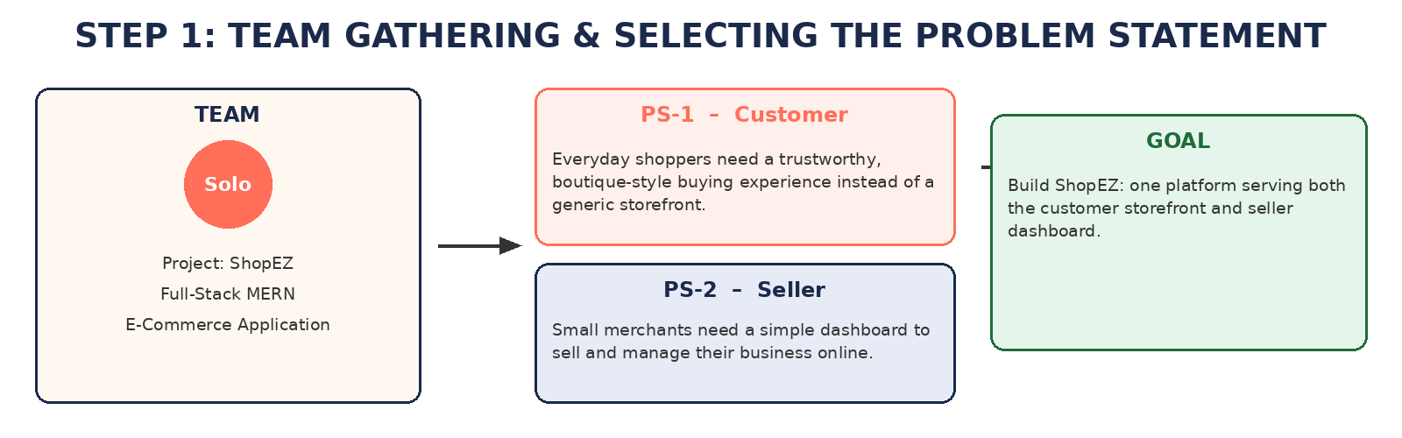
Step-2: Brainstorm, Idea Listing and Grouping
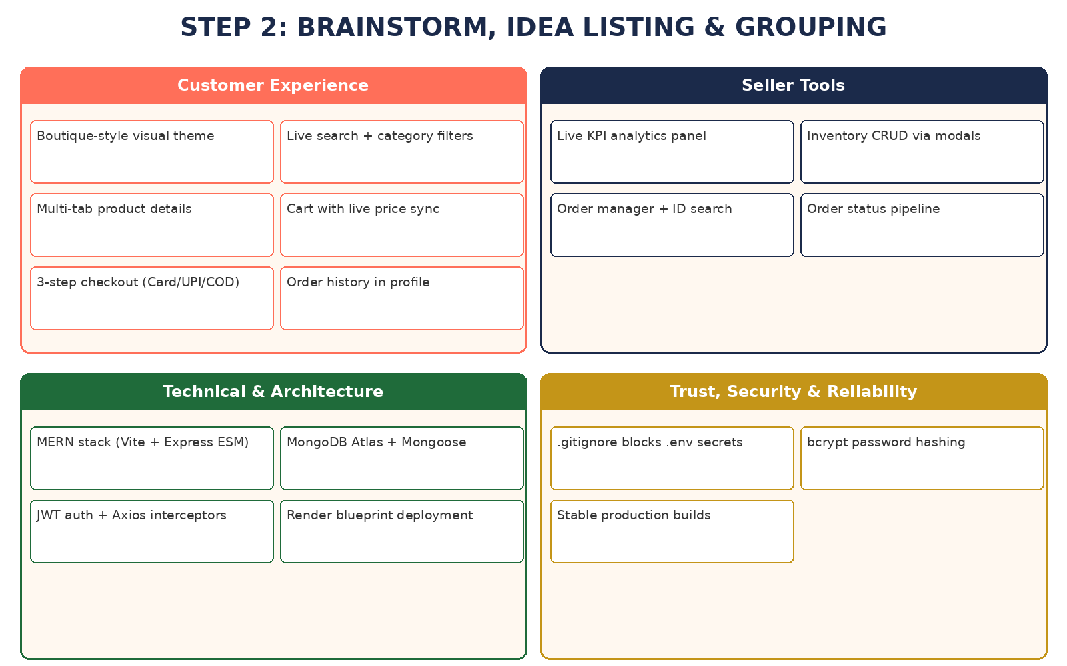

Step-3: Idea Prioritization
